

**MODULE 5**

**INDIVIDUAL LAB 2 WITH APACHE SPARK**

Submitted By:

**HARSHIT GAUR**

MASTER OF PROFESSIONAL STUDIES IN ANALYTICS

ALY 6110 : DATA MANAGEMENT AND BIG DATA

OCTOBER 23, 2022

Submitted To: **PROF. DAYA RUDHRAMOORTHI**

# **Java and Apache Spark Installation**

1. Java was already installed in my system. I have updated it to the latest version available for MacOS.

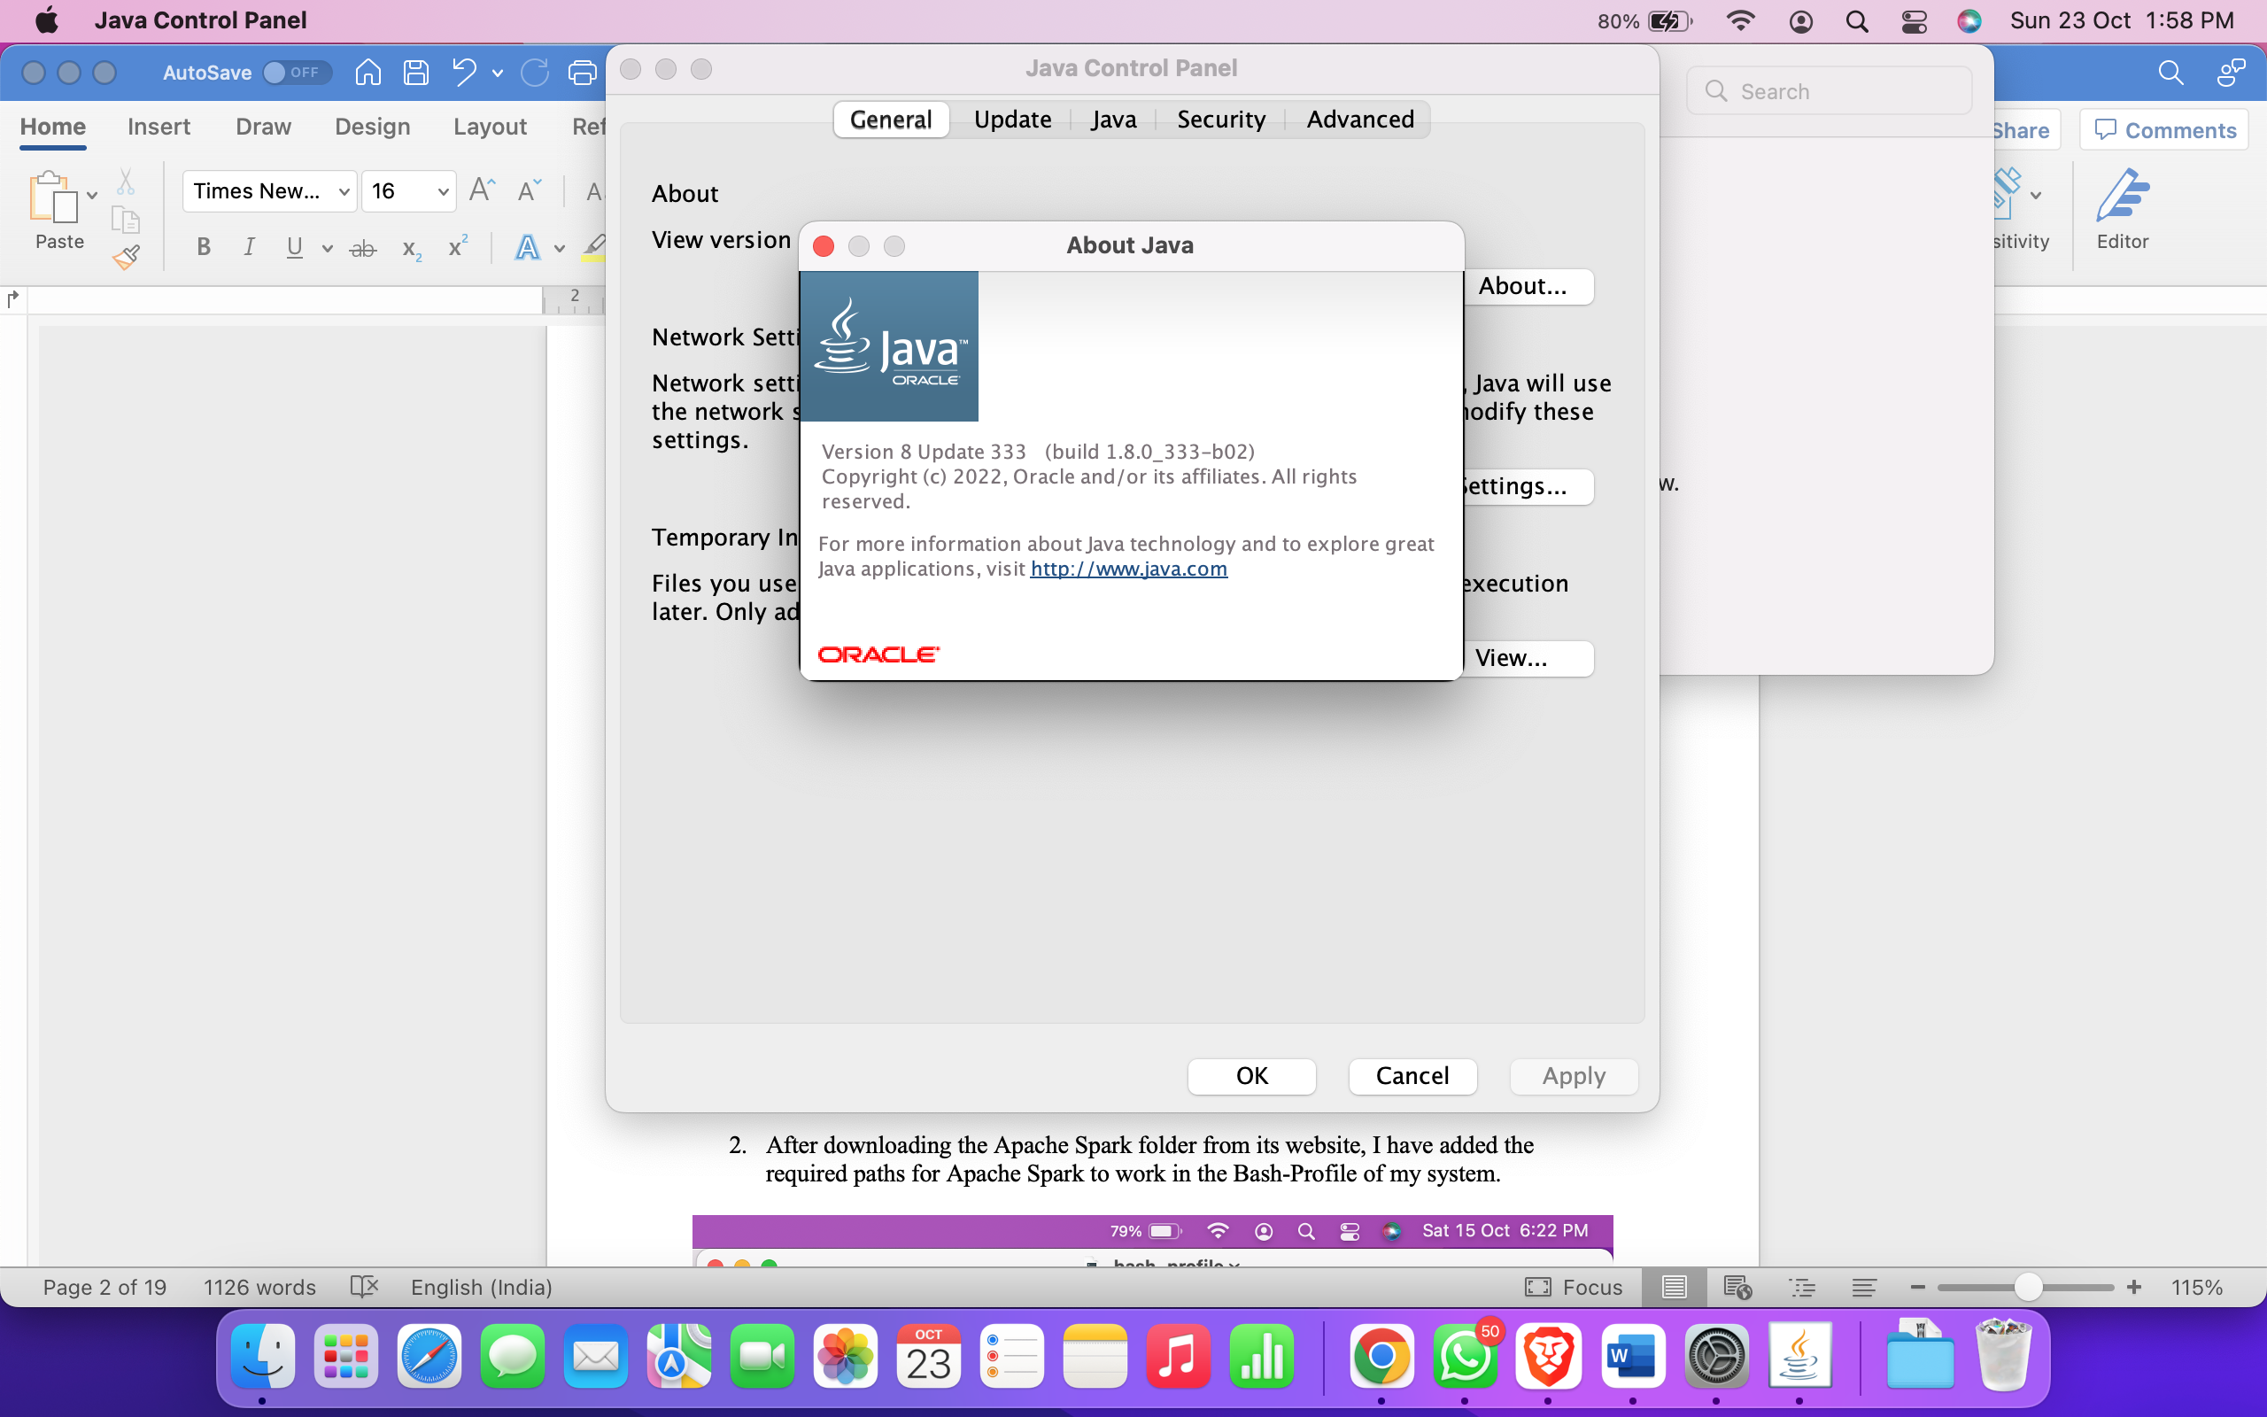

1. After downloading the Apache Spark folder from its website, I have added the required paths for Apache Spark to work in the Bash-Profile of my system.

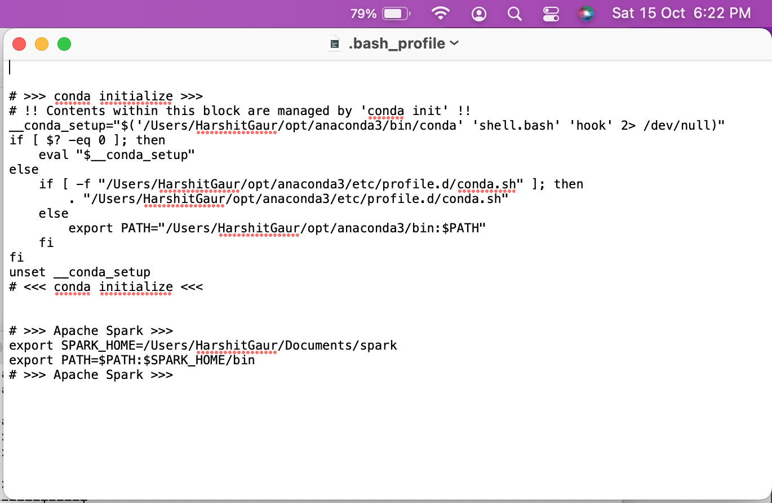

1. Updating the Bash-Profile of my system after making changes and running the ‘Spark Shell’ to check if changes have reflected or not.

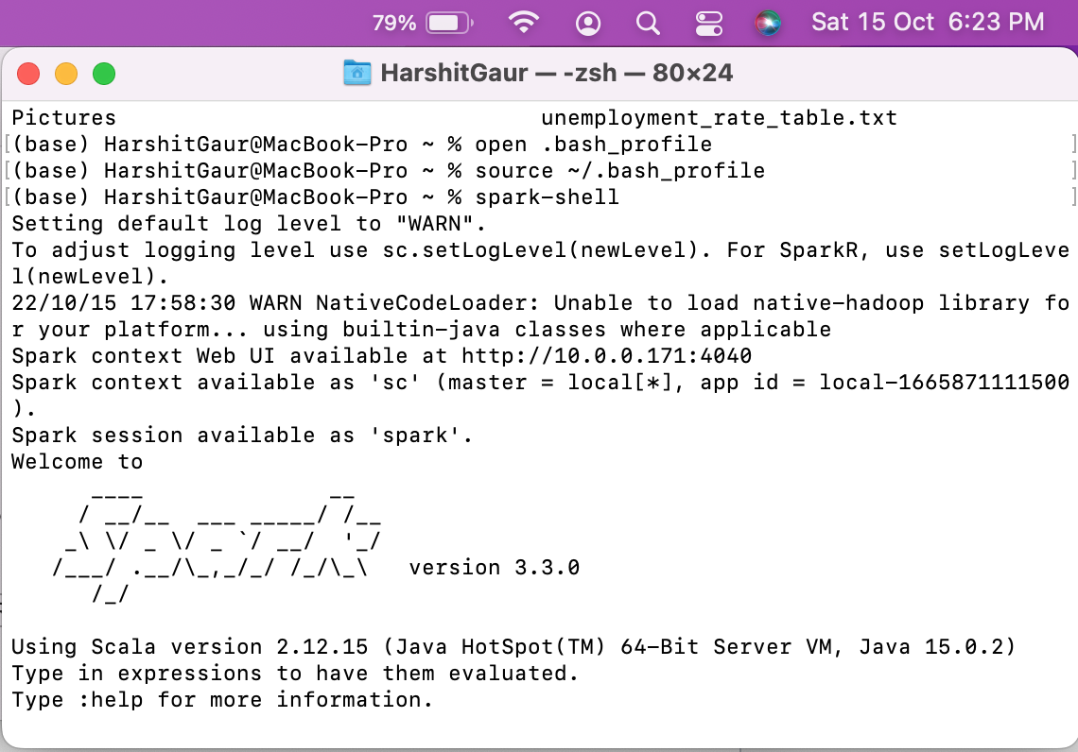

1. To verify if spark has installed properly, running some commands in Scala language.

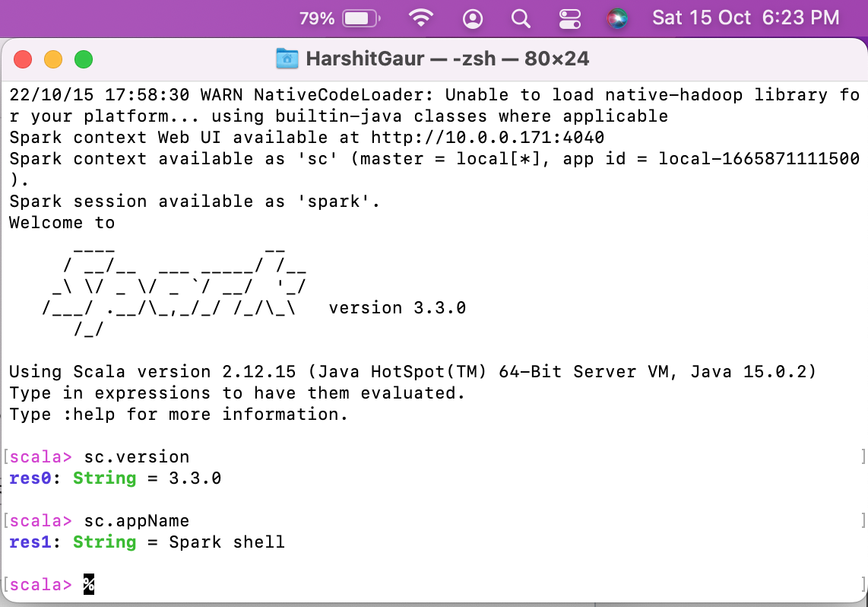

1. For further verification with data, running some more commands to check it is working with data and its manipulation.

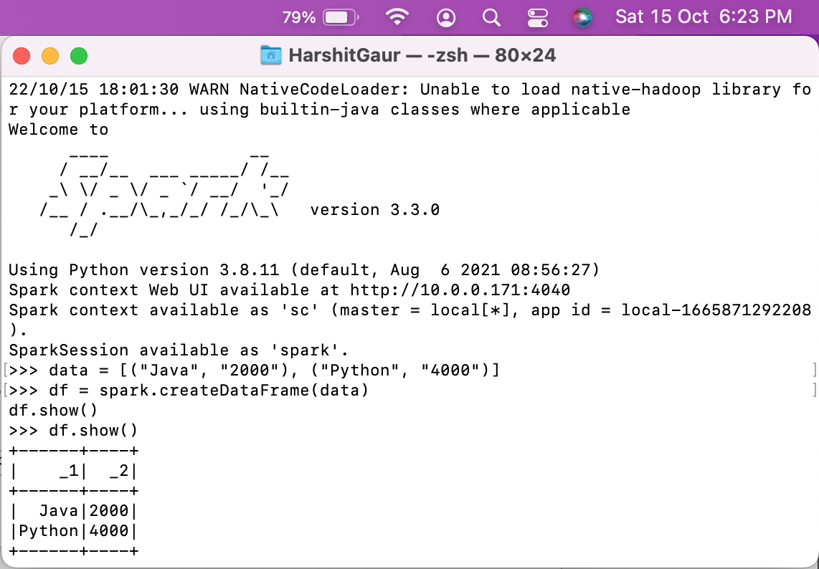

1. Running the Spark Shell for ‘Word Count Generator’ application.

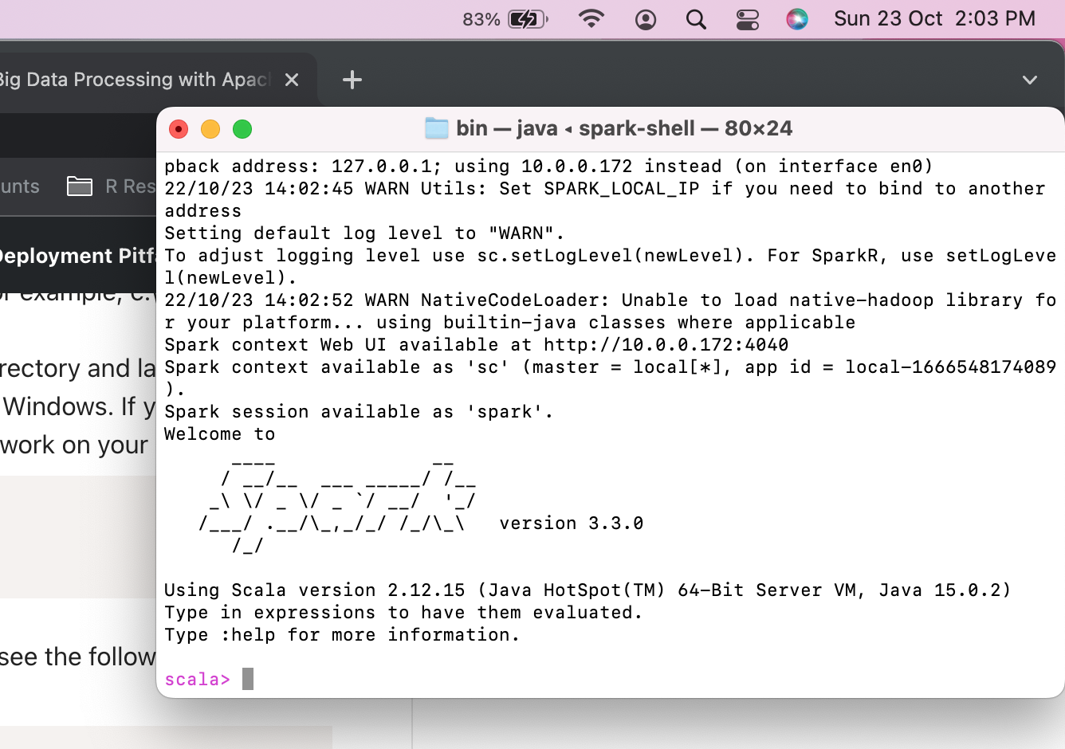

1. PySpark was installed properly and successfully last week for the previous assignment.

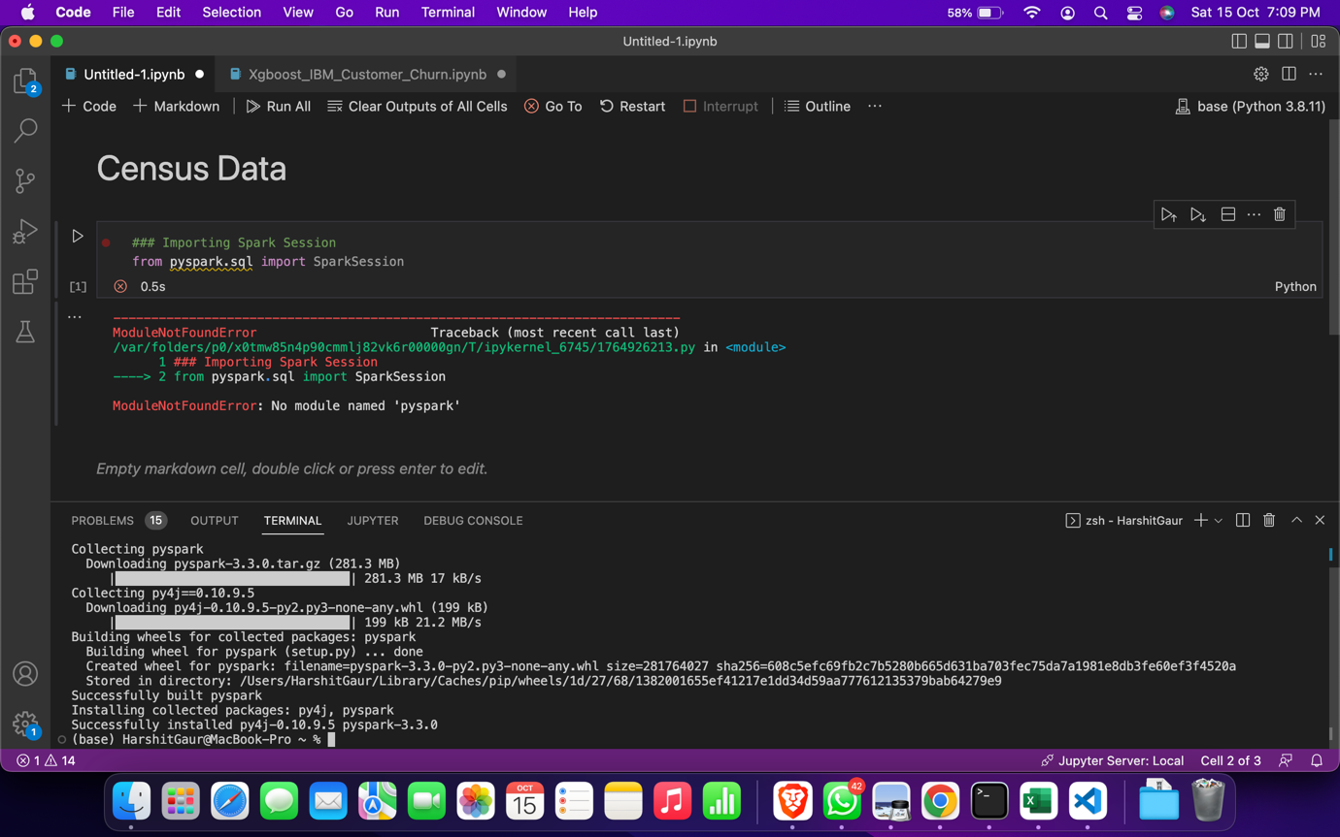

1. PySpark library has also been properly imported into the IPYNB notebook after installation.

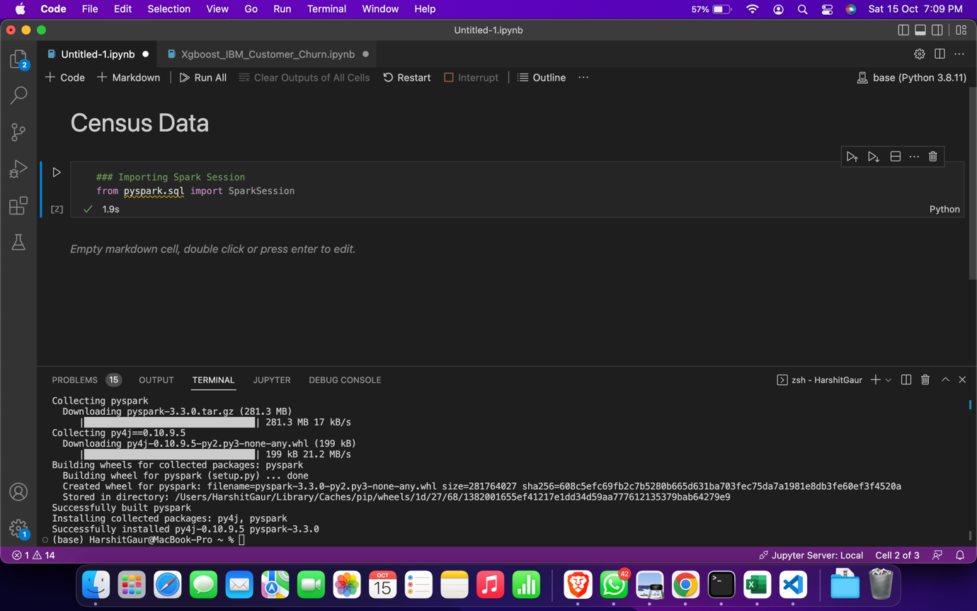

# **Readme.MD File**

1. Importing Spark Libraries.

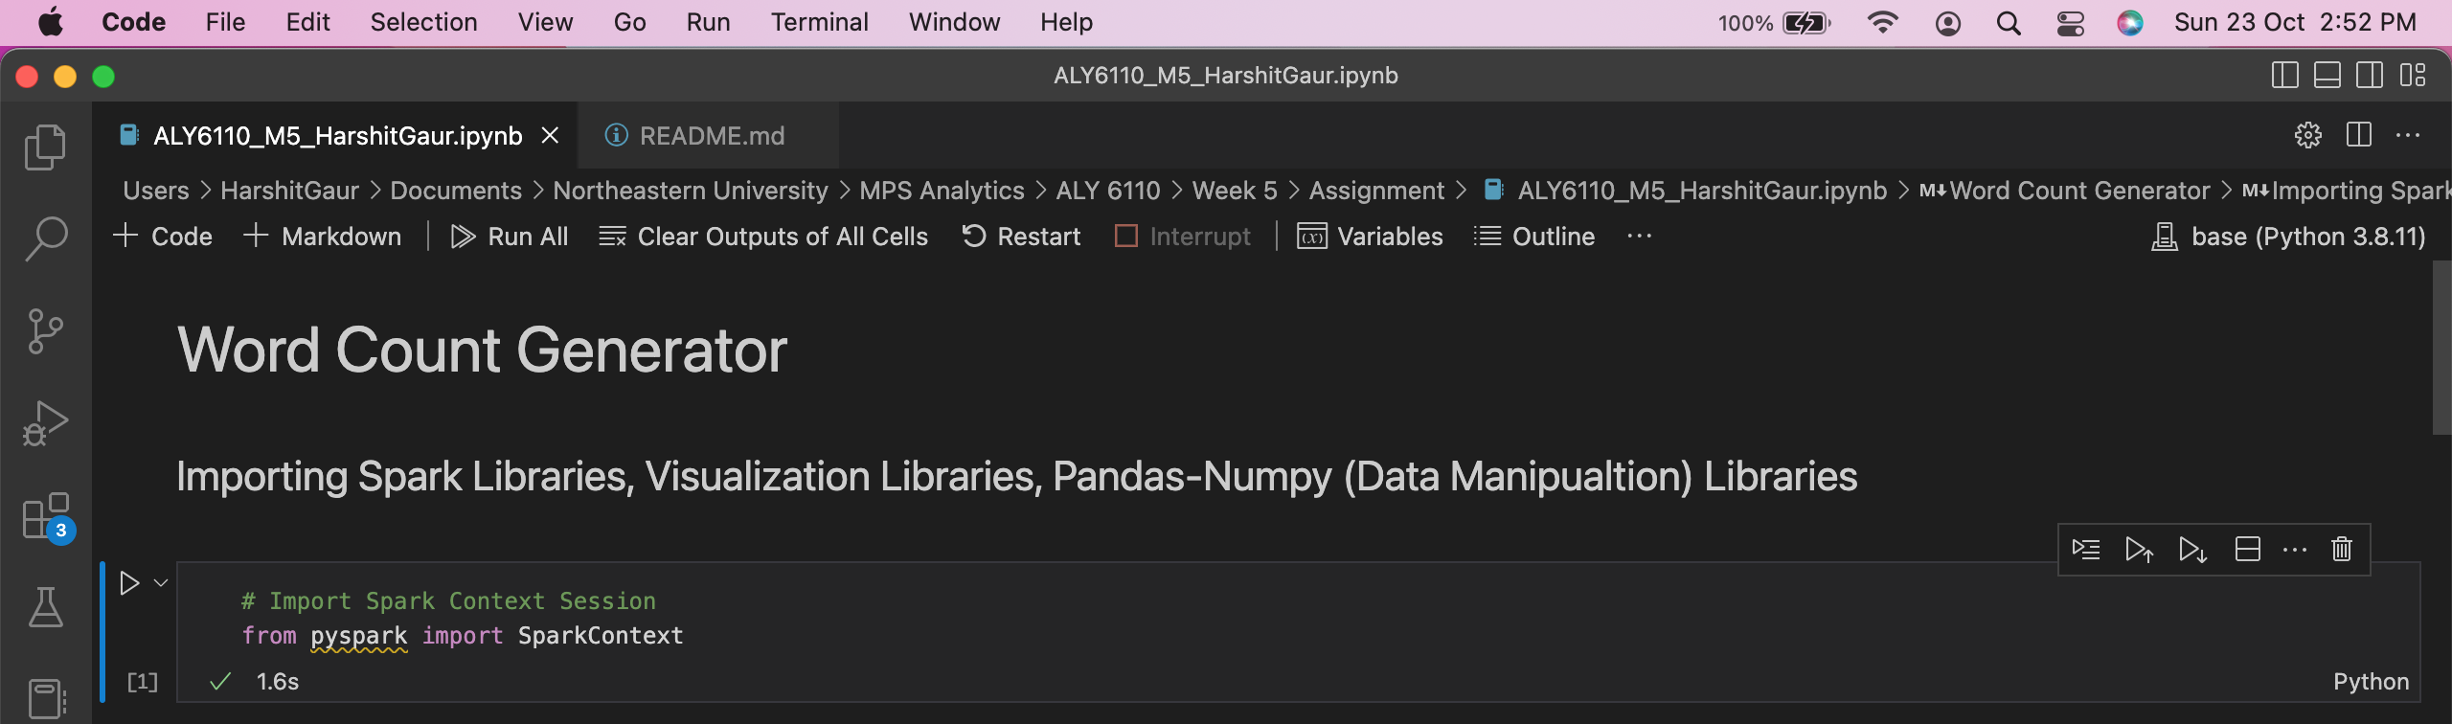

1. Starting “Apache Spark Context” connection with Python.

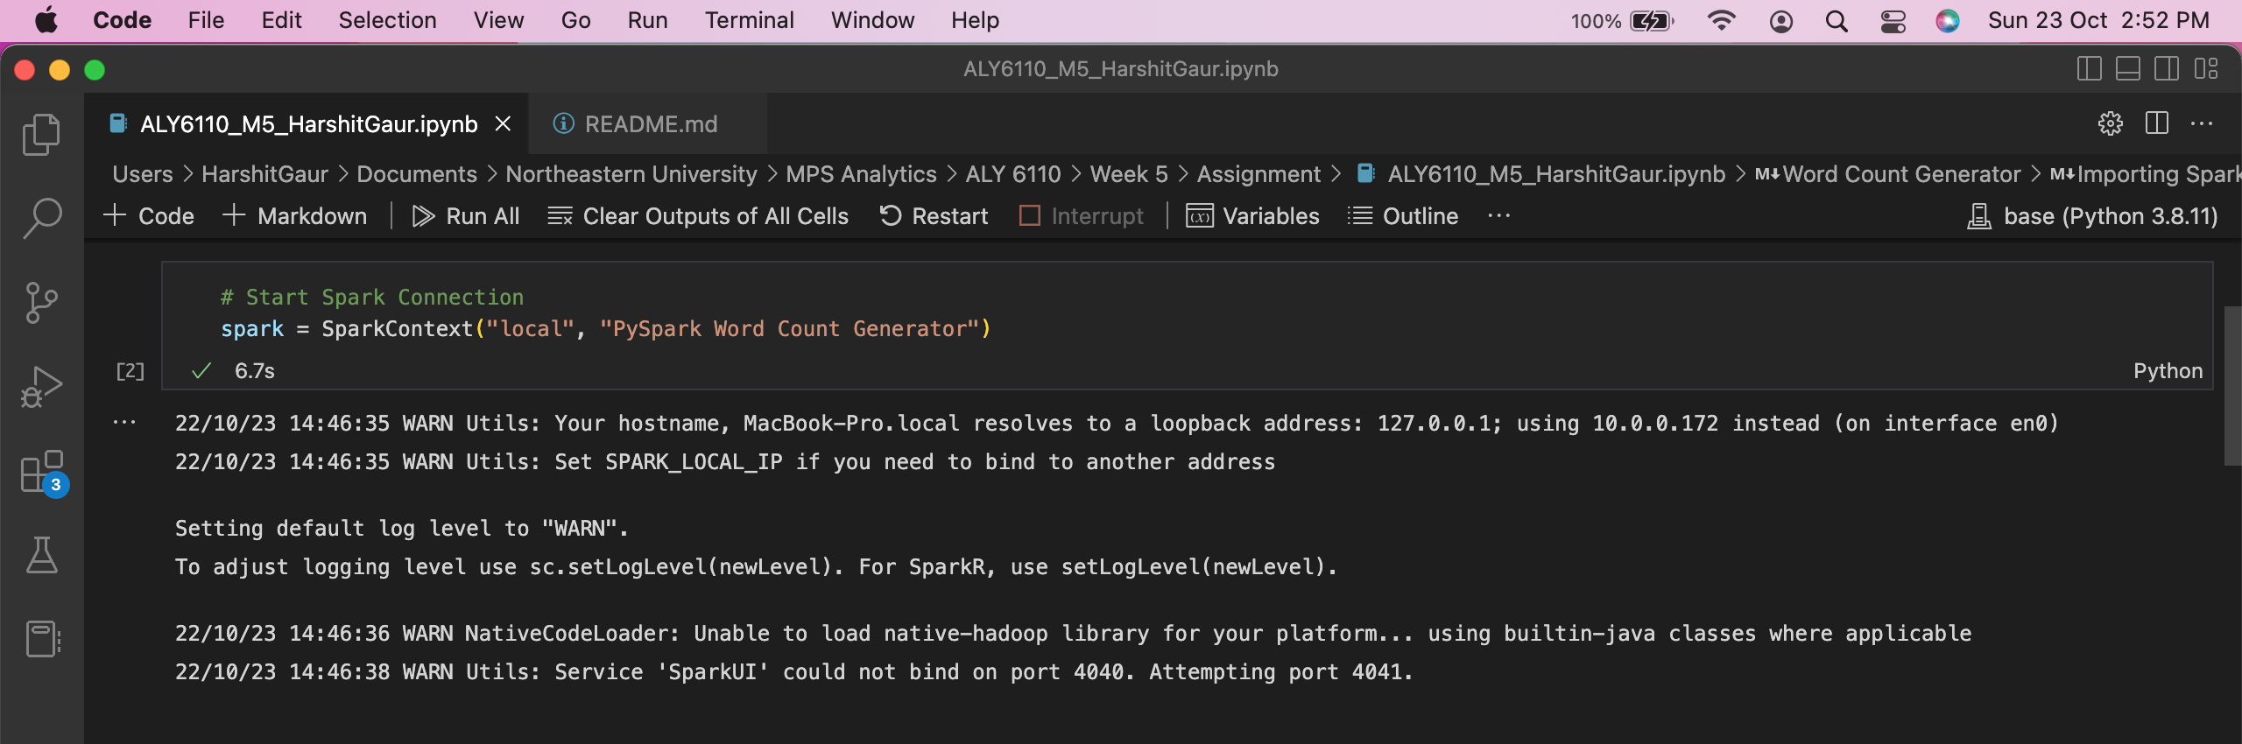

1. Loading the Text File (Readme.MD) using PySpark.

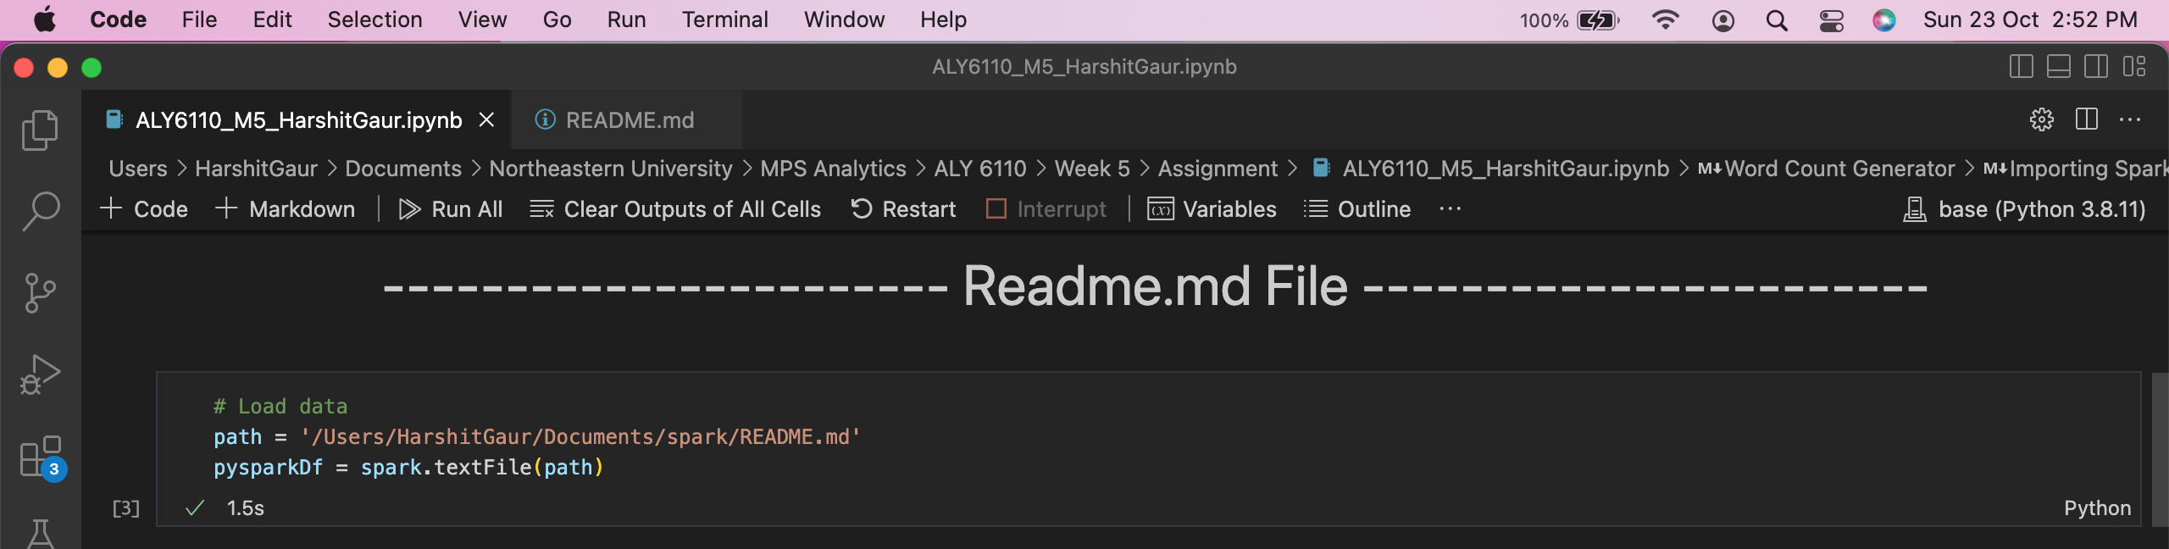

1. The data of the readme file has been cached so that Spark doesn’t have to compute the data on every execution of a process. Cache function has stored the RDD data in the cache.

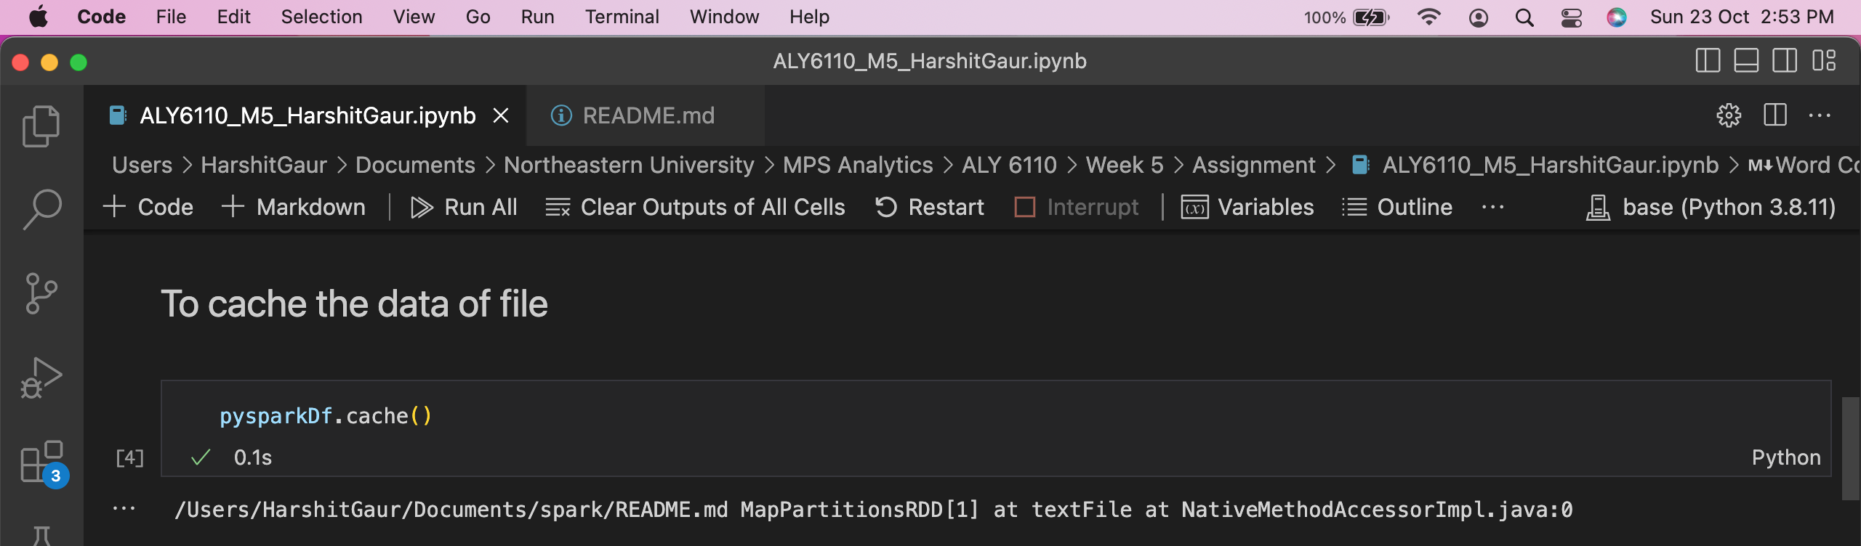

1. To check the count of lines in the data.  
   ***The count of Lines in the Readme file: 124***

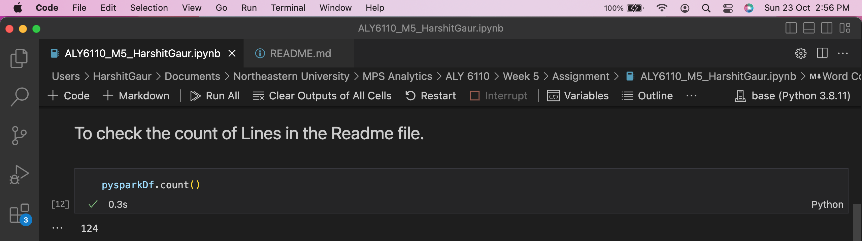

1. The next step is to split the data into lines for further processing.

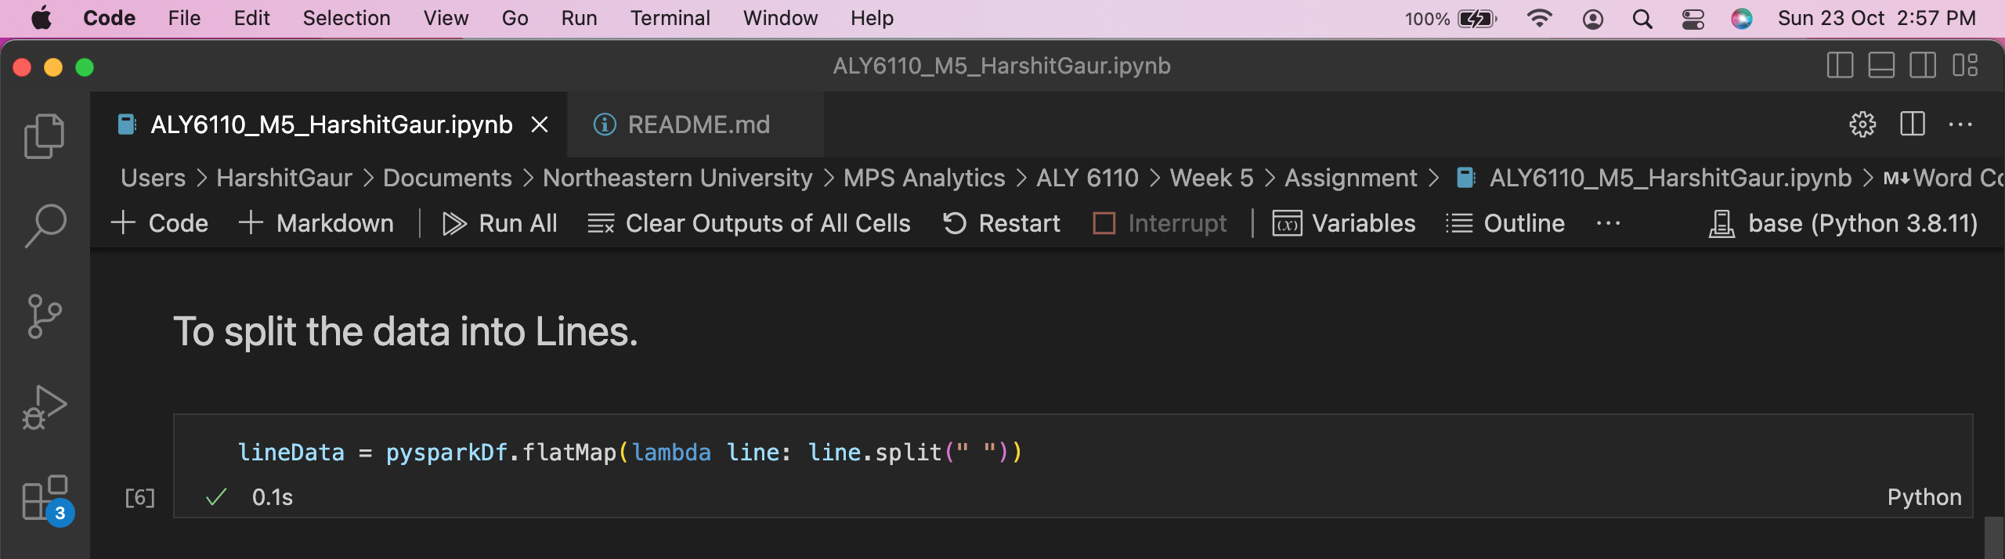

1. The dataset is processed to generate the word count list.

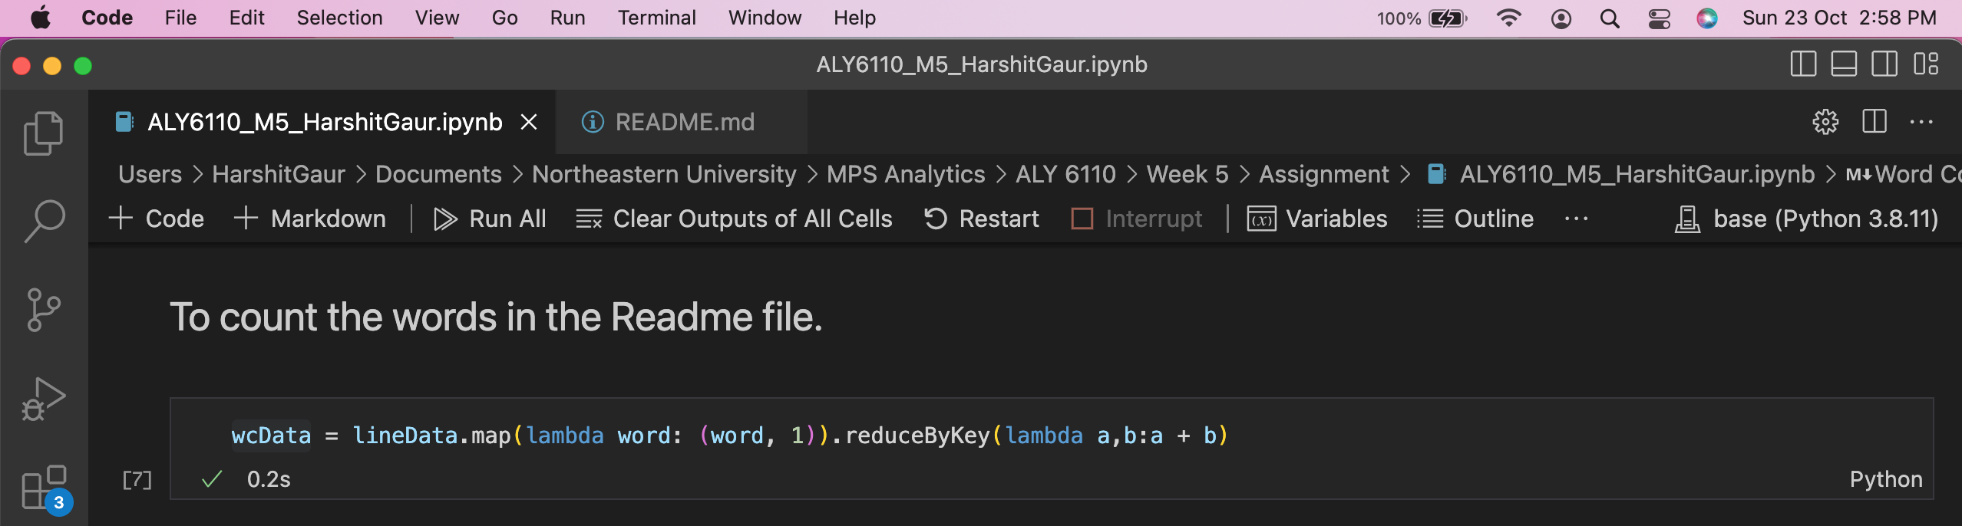

1. To show the generated Word Count List of the Readme file.

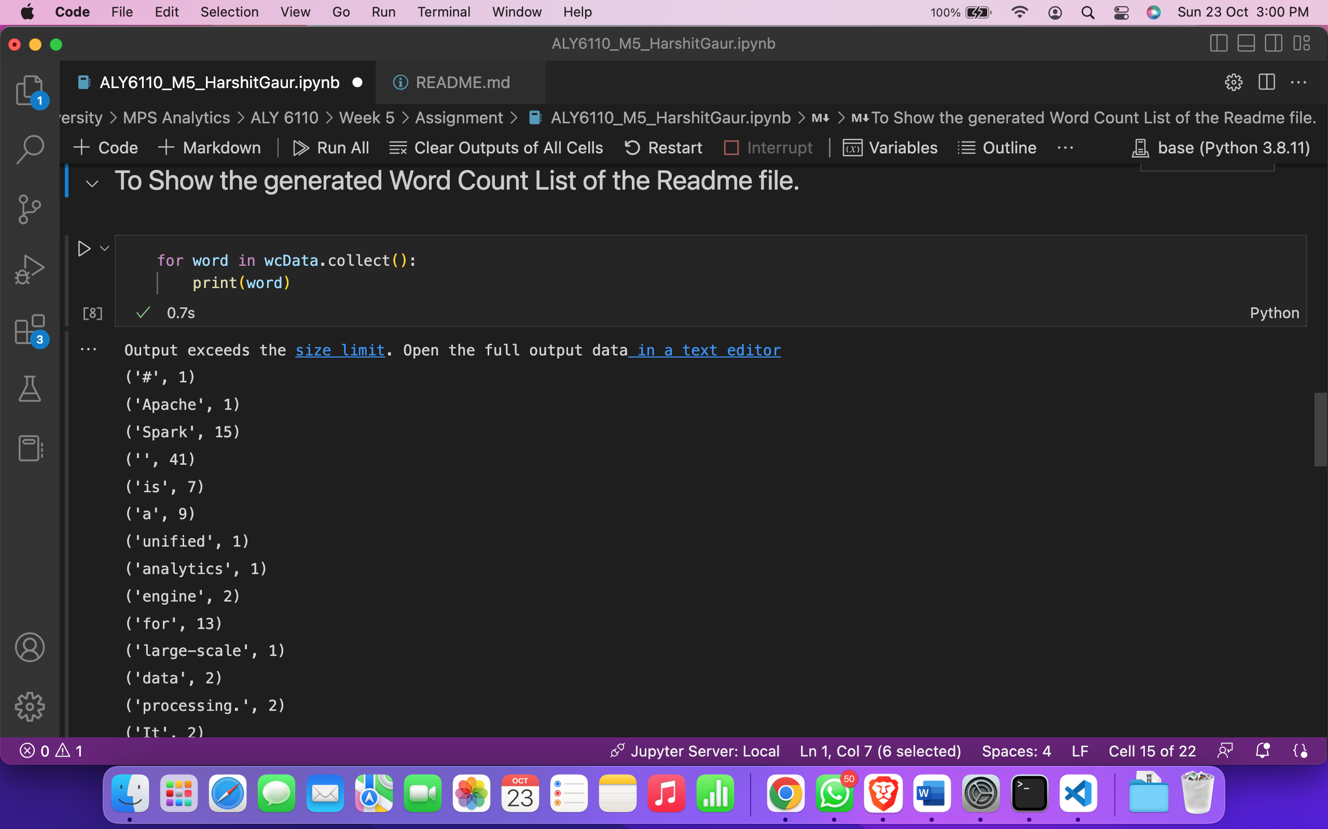

## **Questions**

1. How many times is the word "Hadoop" counted when the tutorial has printed out all the word counts?

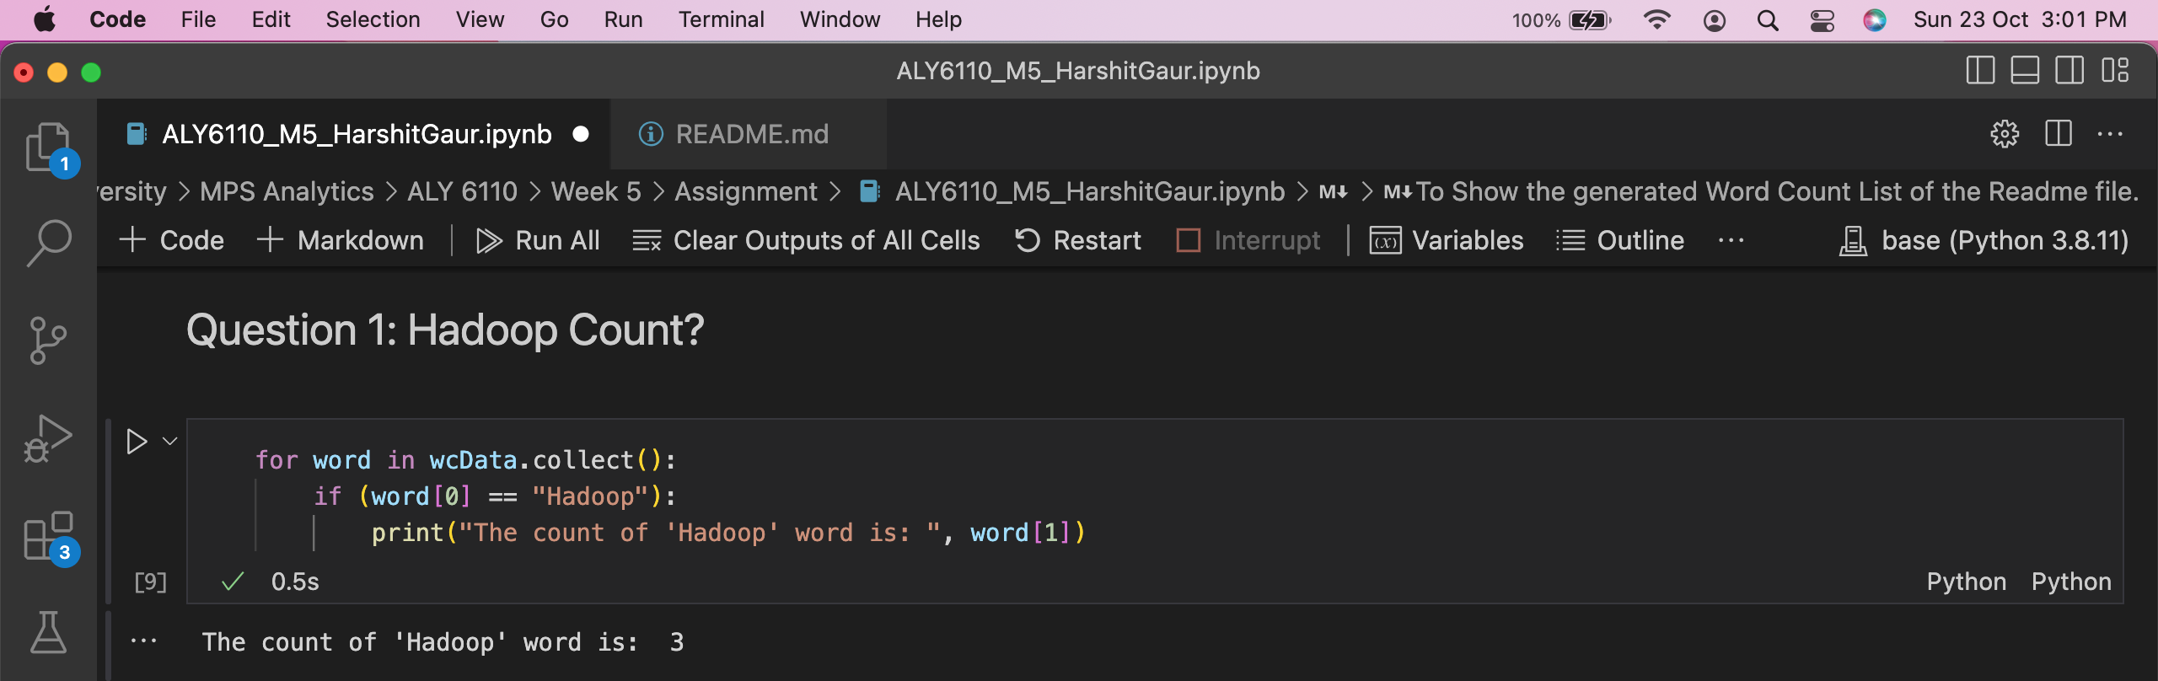

**The count of “Hadoop” in the Readme file: 3**

1. Which is the most common word used in the file? How many times does the word occur?

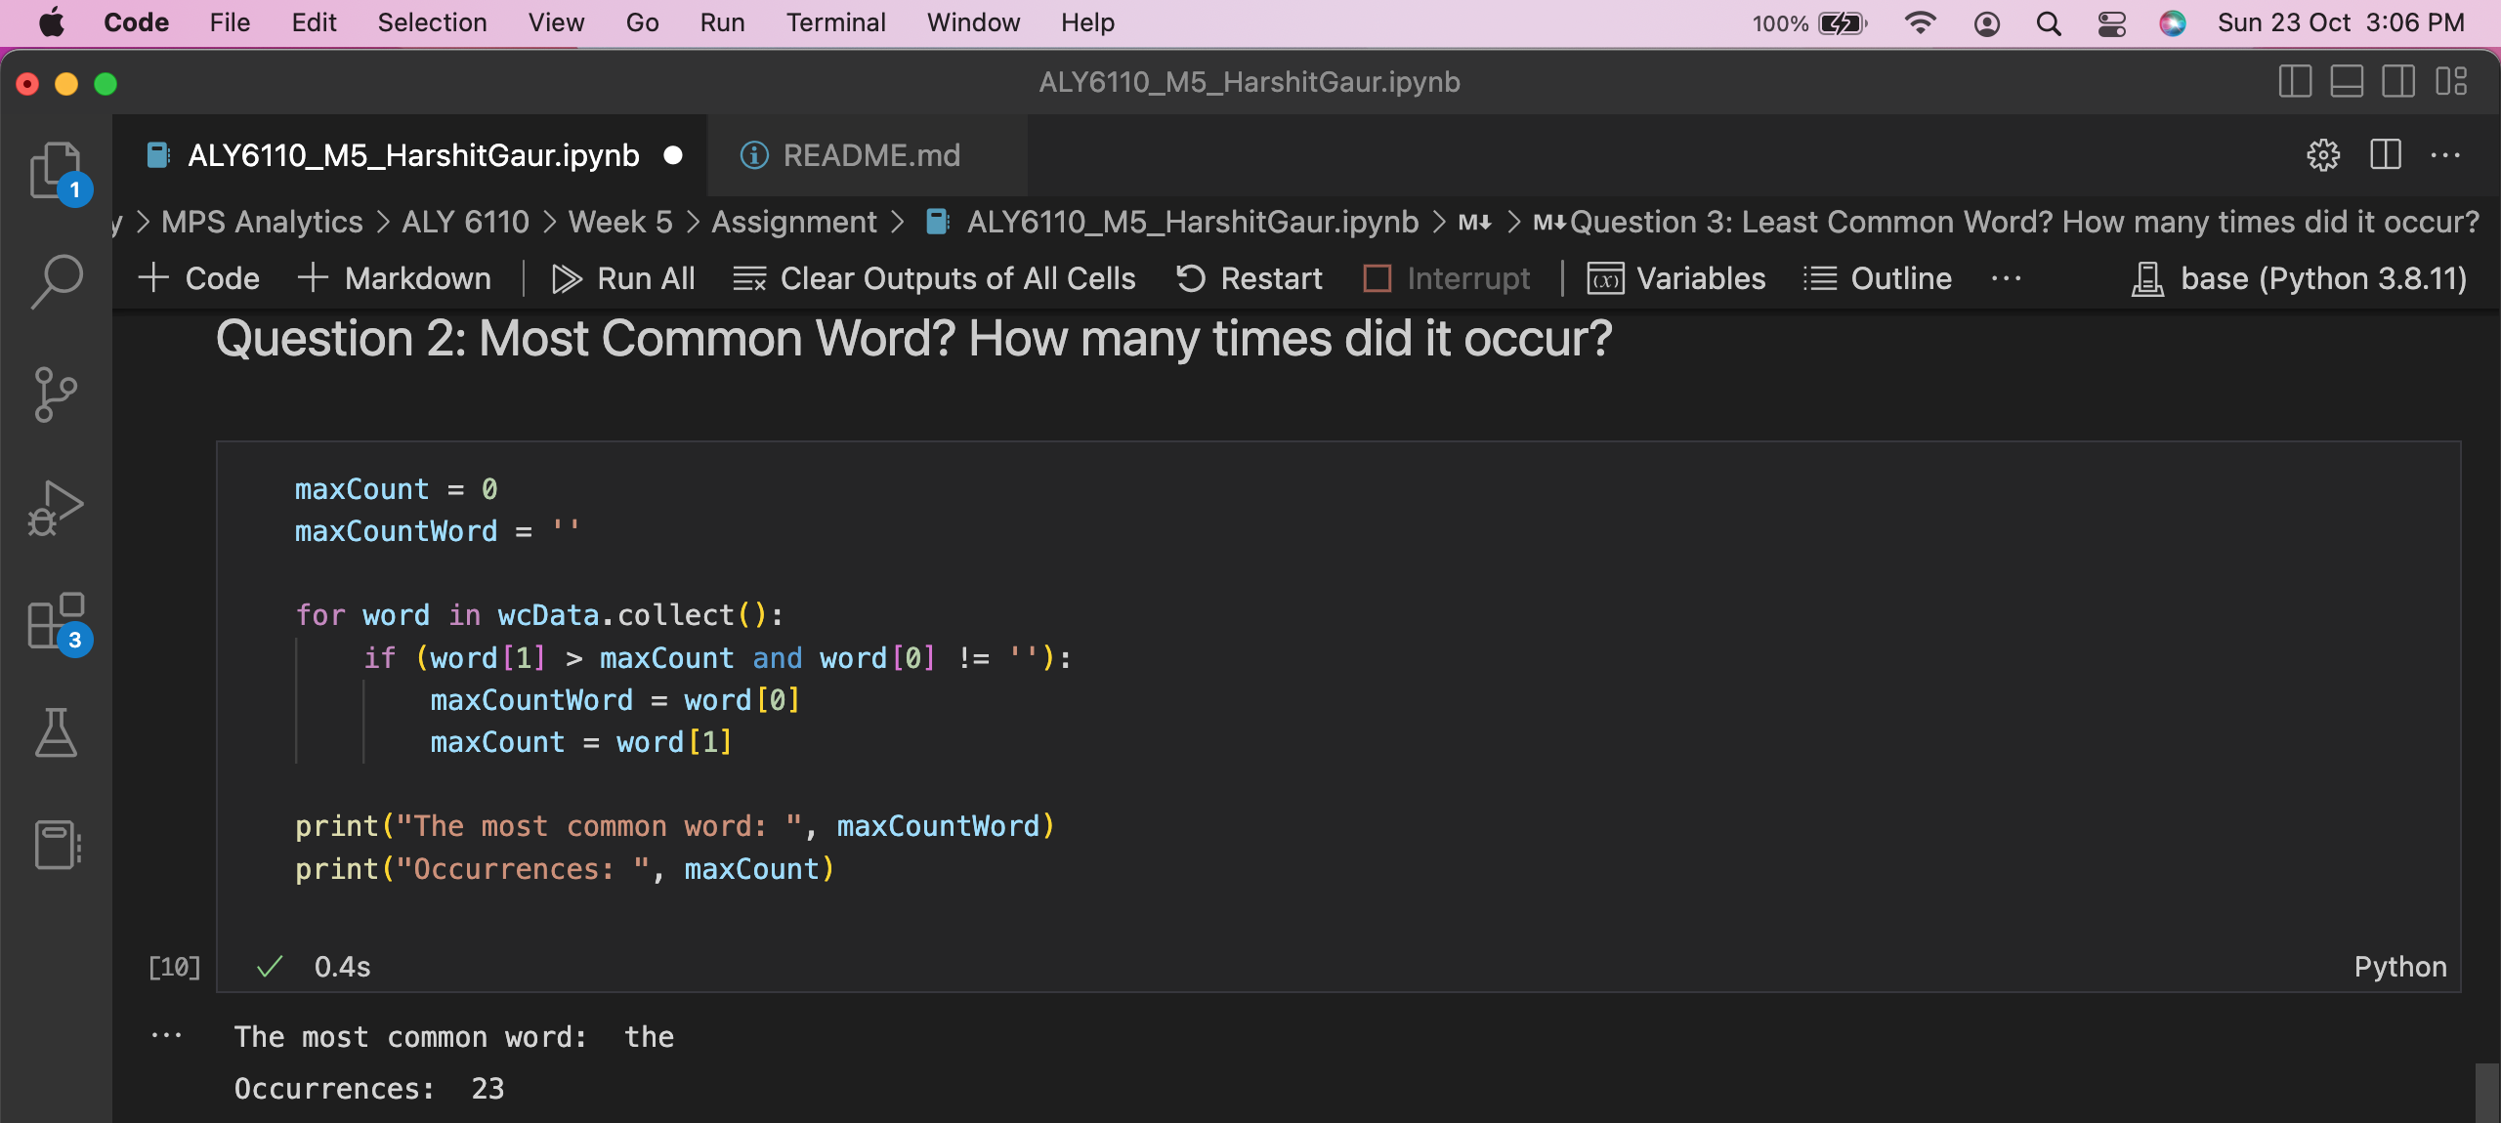

**The most common word: “the”  
with Occurrences: 23**

1. Which word occurs the fewest times? How many times does the word occur?

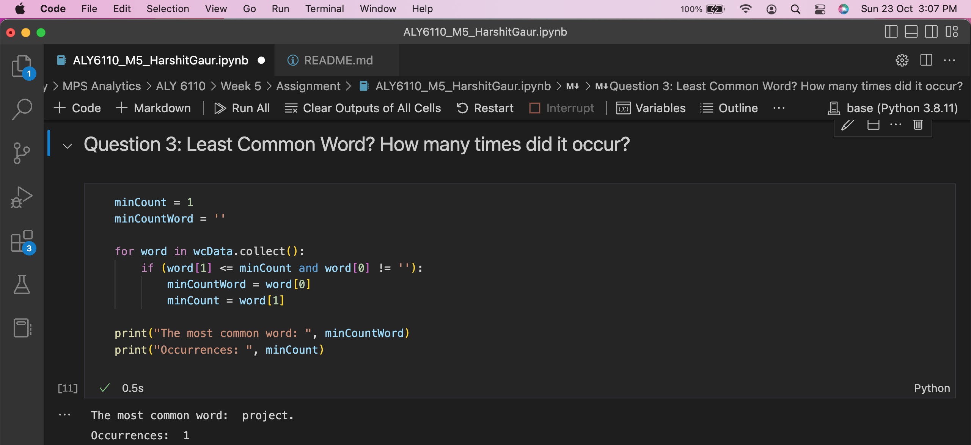

**The least common word: “project”  
with Occurrences: 1**

## **PySpark Application Web Console UI**

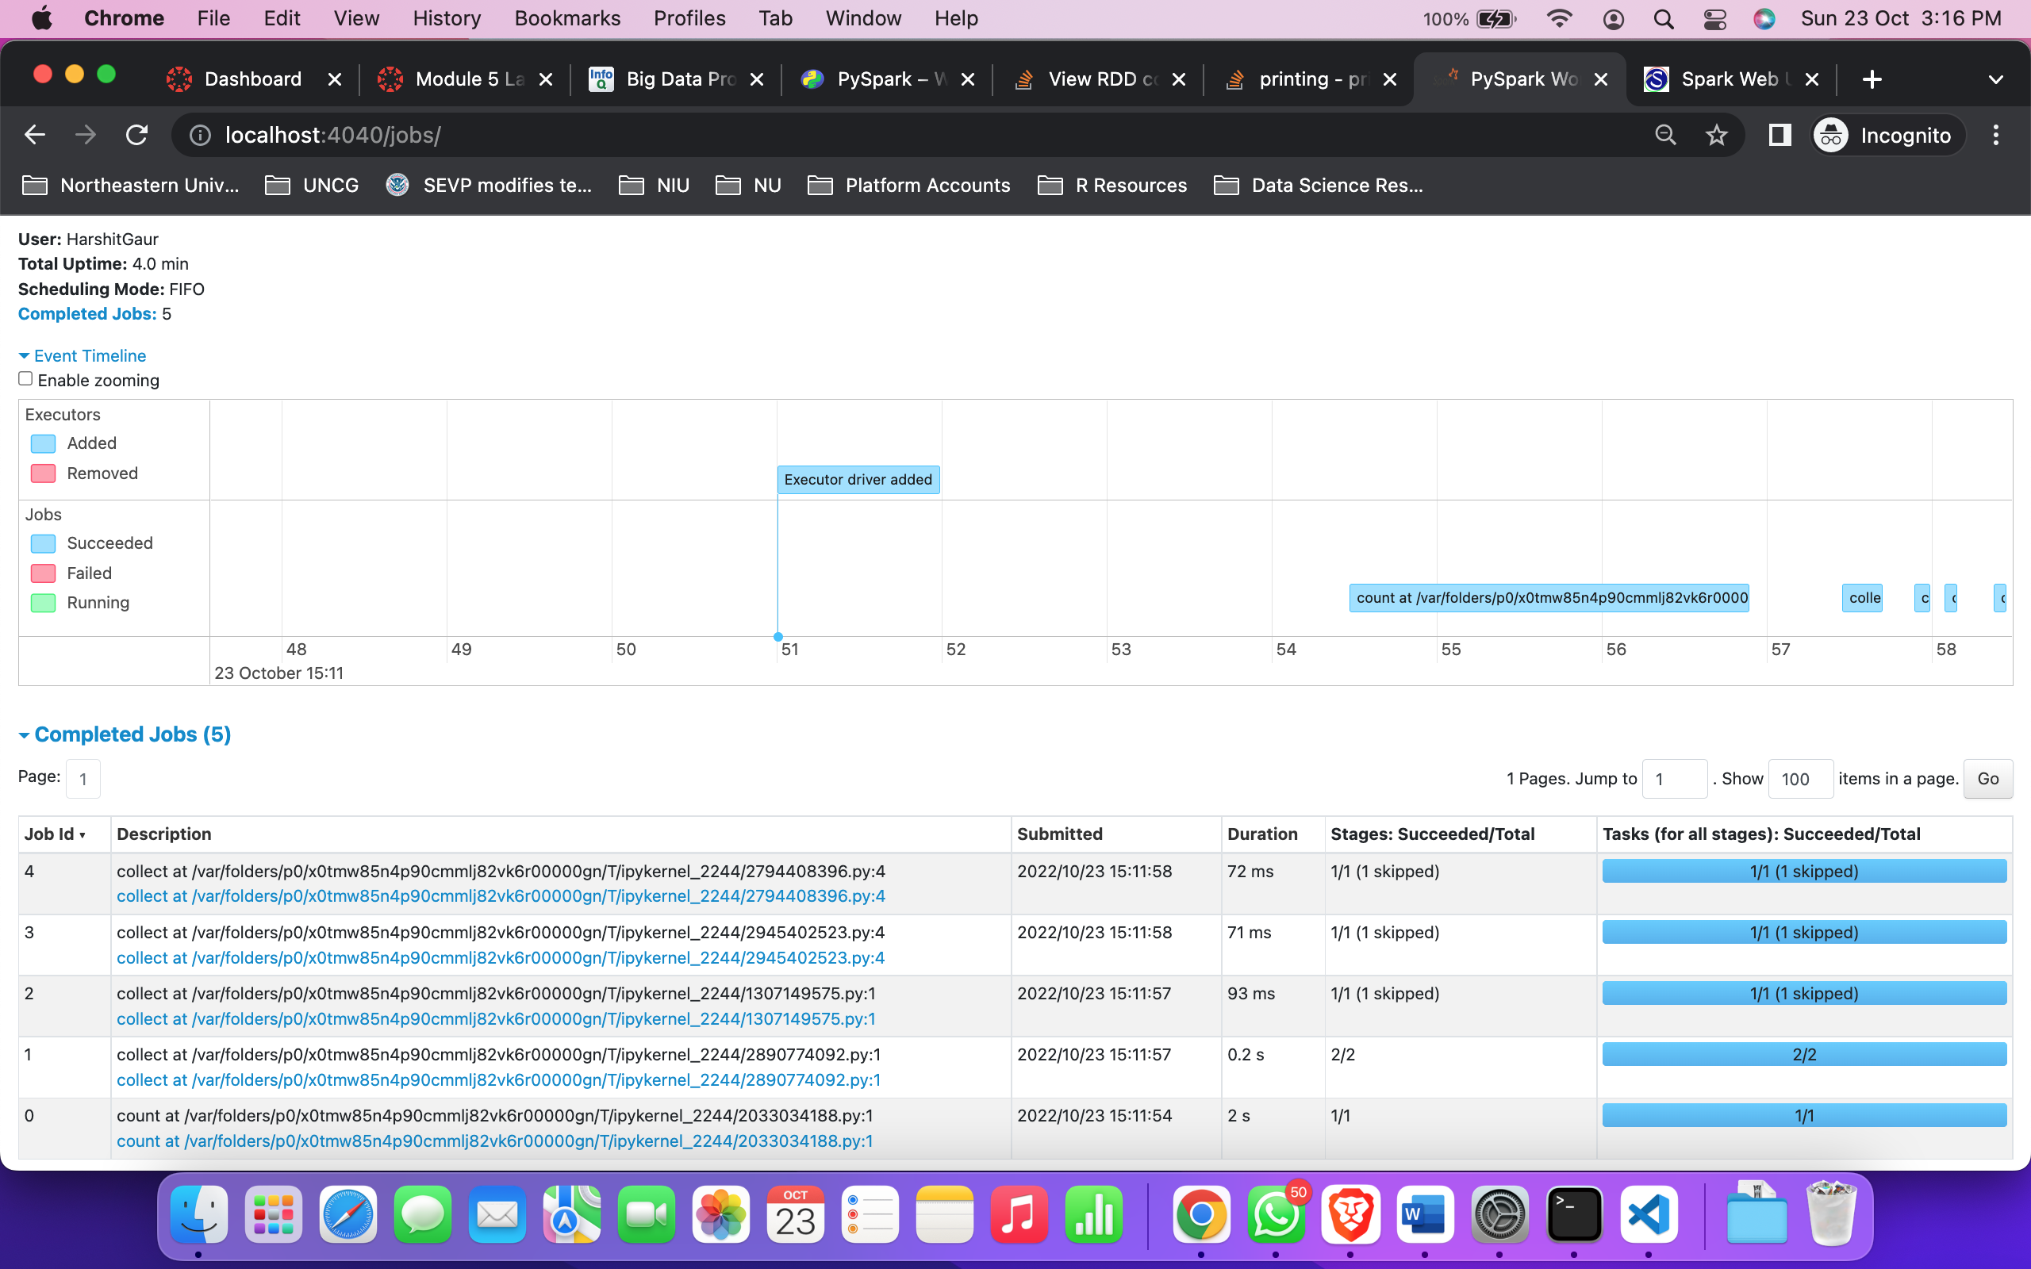

The seconds to complete the “COUNT” job: **2s**